PROJECT DOCUMENTATION
Implement Client Script & UI Policy (Incident)
Project Title: Implement Client Script & UI Policy (Incident) Team ID: SWTID-2026-8065
Team Size: 5
Team Leader: B.Sivaranjani
Team Leader Mail ID: sivaranjani9360729160@gmail.com TeamMembers:S.SabeenaBegum,K.Bhavadharani,V.Prithika,F.Snegavini
Incident records often require consistent and accurate data entry to ensure effective triage, routing, and resolution. However, relying solely on manual checks and user awareness can lead to incomplete, inconsistent, or incorrect submissions, which may affect reporting accuracy, SLA compliance, and overall service quality.
The objective of the project is to demonstrate how ServiceNow client-side controls can enforce Incident data integrity. UI Policies and Client Scripts dynamically make fields mandatory, auto-populate values, control field behavior, and prevent submission when required conditions are not met.

Scenarios
- When an Incident has Impact set to High, the Assignment group becomes mandatory through the UI Policy.
- When Impact is High, the Urgency field becomes read-only and is automatically set to High through the configured controls.
- When a user attempts to save a High-impact Incident without Assigned To, the onSubmit Client Script prevents the save and displays an error.
- When a user attempts to edit State directly from the Incident list, the onCellEdit Client Script blocks the change and asks the user to open the Incident.

Technical Architecture
The project uses ServiceNow Incident forms and lists as the user-facing layer. UI Policies and Client Scripts provide the client-side control layer. Incident records and their fields provide the data layer.
Architecture flow: User → ServiceNow Incident Form/List → UI Policies & Client Scripts → Incident Records
The configured controls are: High Impact Control UI Policy, Urgency UI Policy Action, onChange Client Script, onSubmit Client Script, and onCellEdit Client Script.

Architecture Components
Component | Description | Technology
Incident Form/List | ServiceNow interface used to create, view | laSyeerrviceNow
UI Policy | High Impact Control applies controls when | ServiceNow UI Policy
UI Policy Action | Assignment group is mandatory and Urgen | oSneirsvimceNt.ow UI Policy Act
Client Scripts | onChange, onSubmit and onCellEdit scripts | tdSbaetirhovanicveioNr.ow Client Scripts

i

Component | Description | Role | Technology
Incident Records | Stores Incident data including Impact, Assig | Dnmateanltagyreorup, Urgency, Assigne | SdeTrovicaenNdoSwtaItnec.ident table

Pre-requisites
- ServiceNow instance access with administrative or configuration access.
- Knowledge of Incident Management UI Policy.
- Knowledge of UI Policy Actions.
- Knowledge of Client Scripts.
- Understanding of form validation.

Project Workflow
- Milestone 1: Configure UI Policy and UI Policy Action for High-impact Incidents.
- Milestone 2: Configure onChange, onSubmit and onCellEdit Client Scripts.
- Milestone 3: Test mandatory enforcement and successful save behavior.
- Milestone 4: Test reverse condition, list-edit blocking and form-based updates.
- Milestone 5: Review the complete Incident behavior and confirm configured controls.
- Milestone 6: Conclude the configuration and document the resulting data-quality controls.
Milestone 1: UI Policy Configuration Task 1: Create UI Policy on Incident Activity 1: Create UI Policy
- Log in to the ServiceNow instance with administrative or configuration access.
- Navigate to System UI → UI Policies.
- Click New to create a new UI Policy record.
- Fill in the details: Name = High Impact Control; Table = Incident; Active = true.
- Configure the condition: Field = Impact; Operator = is; Value = 1 – High.
- Configure the UI Policy Action so Assignment group is mandatory.
- Set Reverse if false to true.
- Review the configuration and click Submit.

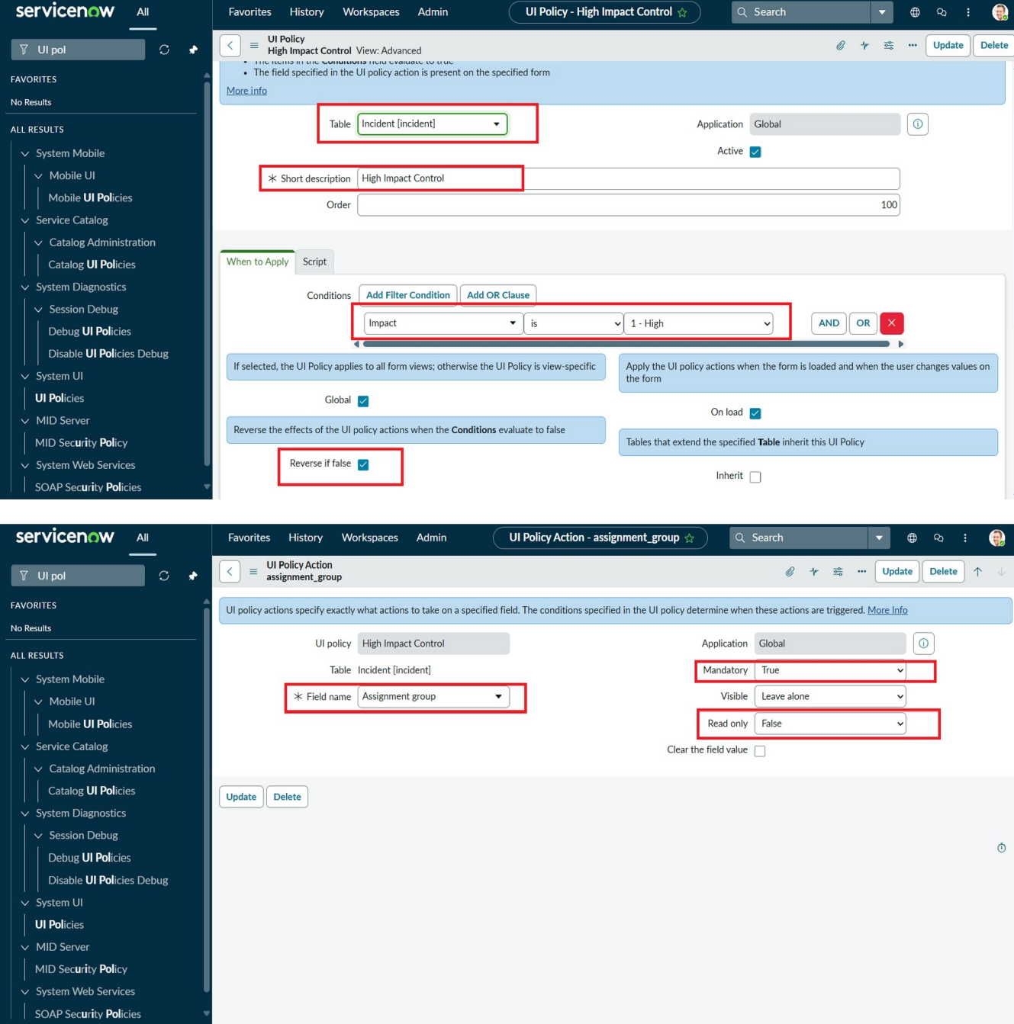

Configuration screenshot – High Impact Control UI Policy
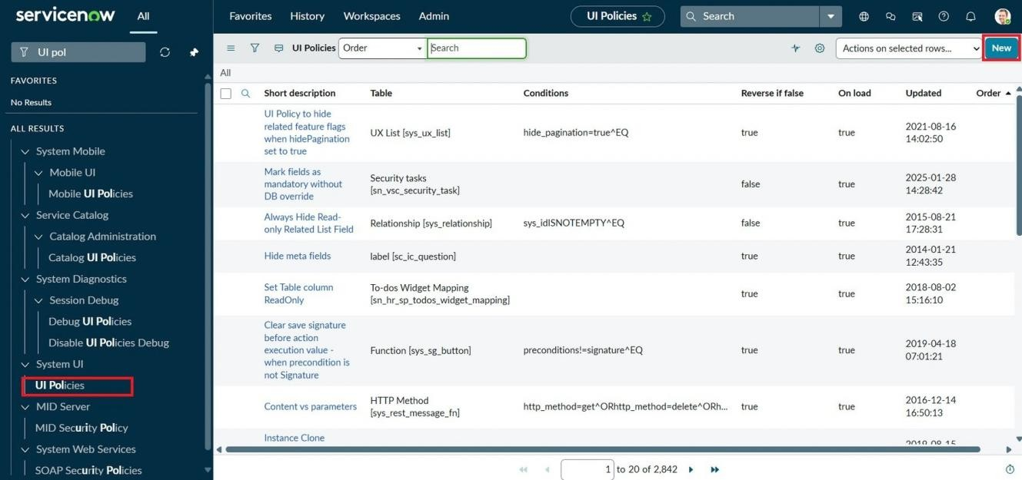
Configuration screenshot – UI Policy condition/action details

Task 2: Create UI Policy Action – Urgency

Activity 1: Configure the Urgency Field
- Open the High Impact Control UI Policy and go to its UI Policy Actions.
- Click New to create a UI Policy Action.
- Set Field name to Urgency.
- Set Read-only to true.
- Leave Visible unchanged.
- Click Submit to save the action.
- Optional verification: open an Incident, set Impact to High, and confirm that Urgency becomes read-only.
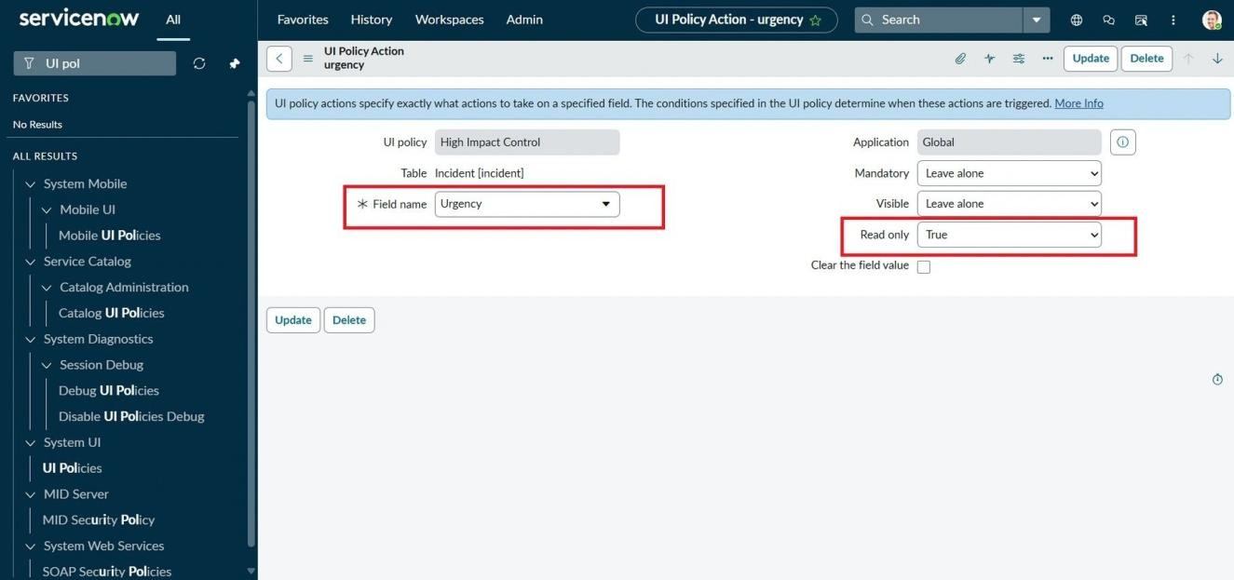
Configuration screenshot – Urgency UI Policy Action

Milestone 2: Client Script Configuration

Task 3: Create onChange Client Script

Activity 1: Create Client Script
- Navigate to System UI → Client Scripts.
- Click New to create a new Client Script.
- Set Name = Auto set urgency for high impact.
- Set Table = Incident, Type = onChange, Field name = Impact, and Active = true.
- Paste the onChange script in the script editor.
- Click Submit to save the Client Script.
- Verify by changing Impact to High on an Incident; Urgency should update automatically.

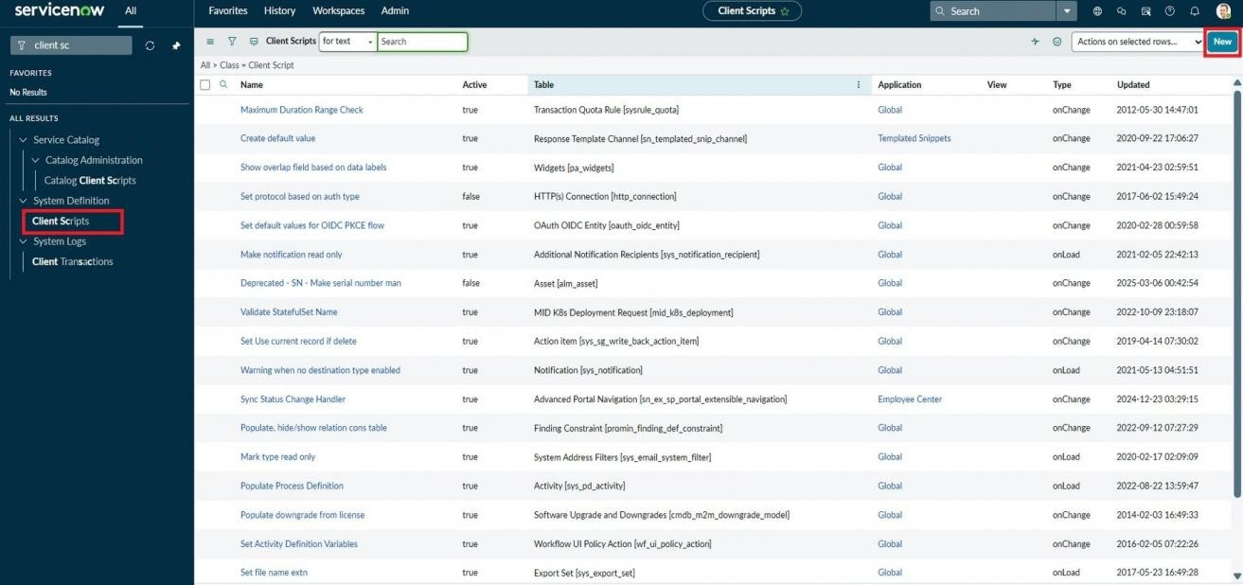
Configuration screenshot – Client Scripts list
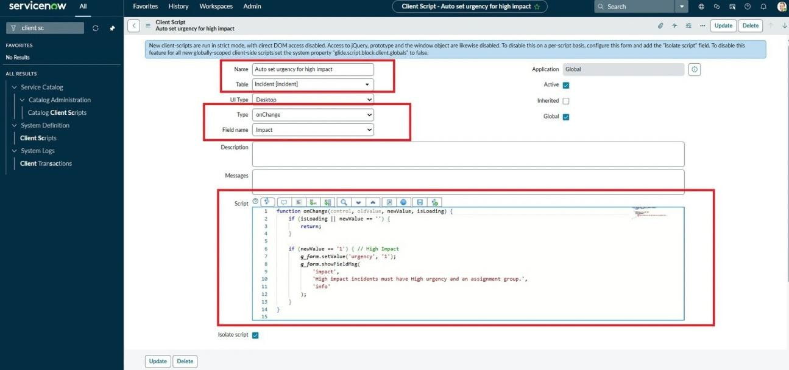
Configuration screenshot – onChange Client Script

Task 4: Create onSubmit Client Script (Save Validation)

Activity 1: Create Client Script
- Navigate to System UI → Client Scripts.
- Click New to create a new Client Script.
- Set Name = Prevent save if Assigned To missing; Table = Incident; Type = onSubmit; Active = true.
- Paste the validation script into the script editor.
- Click Submit to save the Client Script.
- Verify by attempting to save a High-impact Incident without Assigned To; the save should be prevented and a warning displayed.

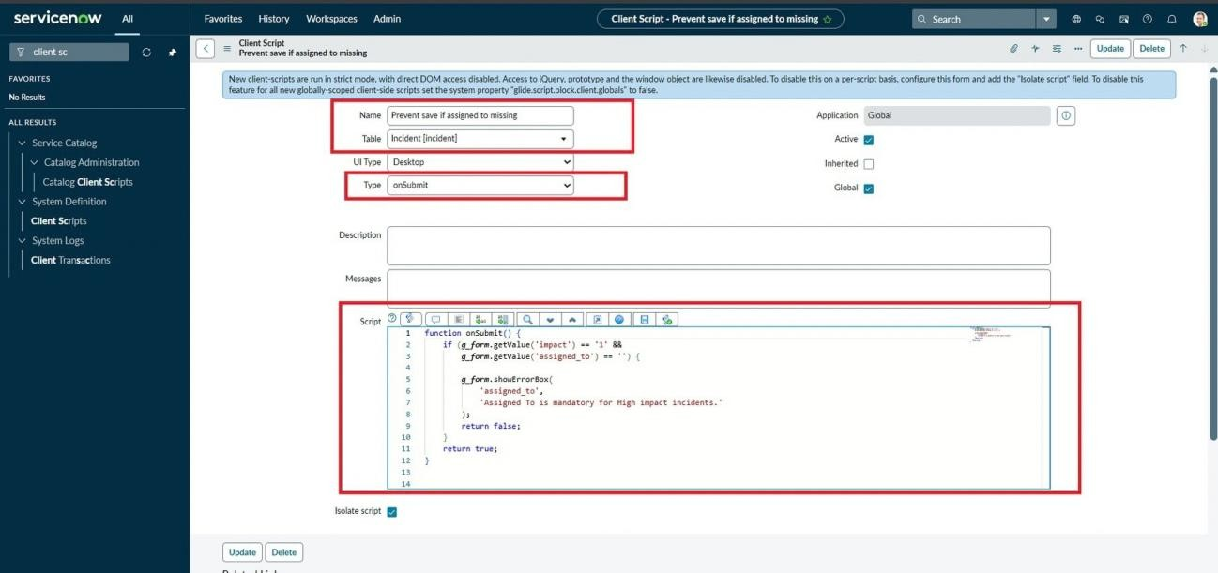
Configuration screenshot – onSubmit Client Script

Task 5: Create onCellEdit Client Script

Activity 1: Create Client Script
- Navigate to Client Scripts and click New.
- Set Name = Prevent state change via list edit; Table = Incident; Type = onCellEdit; Field name = State; Active = true.
- Paste the onCellEdit script into the script editor.
- Click Submit.
- Verify by attempting to change State directly from an Incident list.
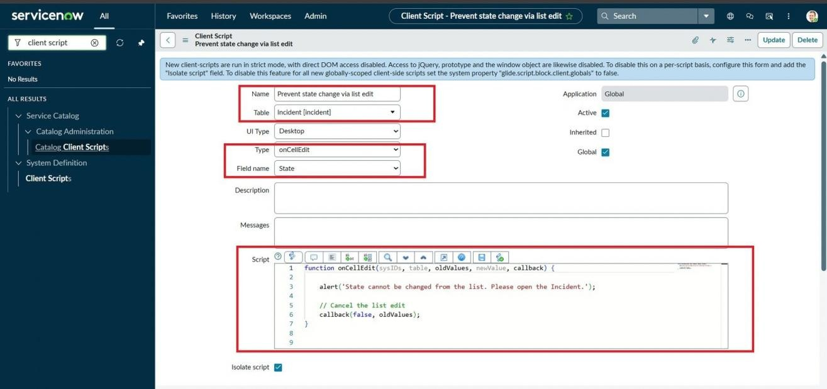
Configuration screenshot – onCellEdit Client Script

Milestone 3: Testing the Configuration

Task 6: Testing the Configuration

Activity 1: Test Mandatory Enforcement
- Navigate to Incident → Create New.

- Set Impact to High and leave Assigned To empty.
- Click Submit.
- Verify that the Incident is not saved and an error indicates that Assigned To is required.
- Confirm that the UI Policy actions and automated urgency behavior work as expected.
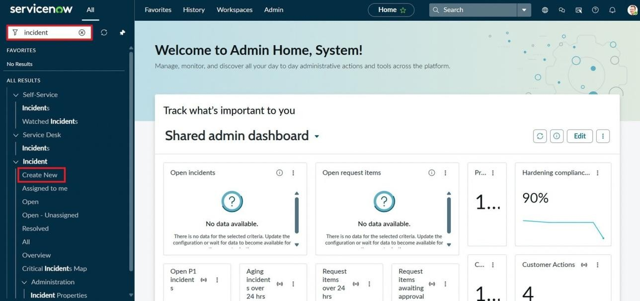
Testing screenshot – Incident form with configured controls
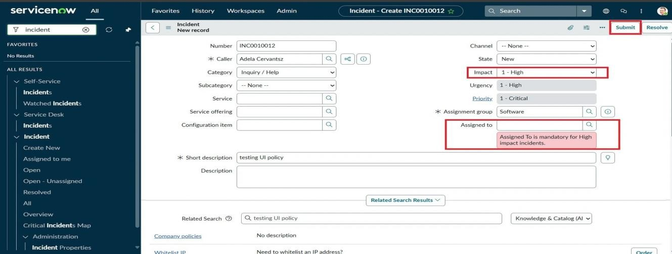
Testing screenshot – validation behavior

Activity 2: Test Successful Save
- Fill the Assigned To field on the Incident form.
- Click Submit.
- Verify that the Incident saves successfully without errors.
- Confirm urgency auto-setting, read-only behavior and State restrictions.

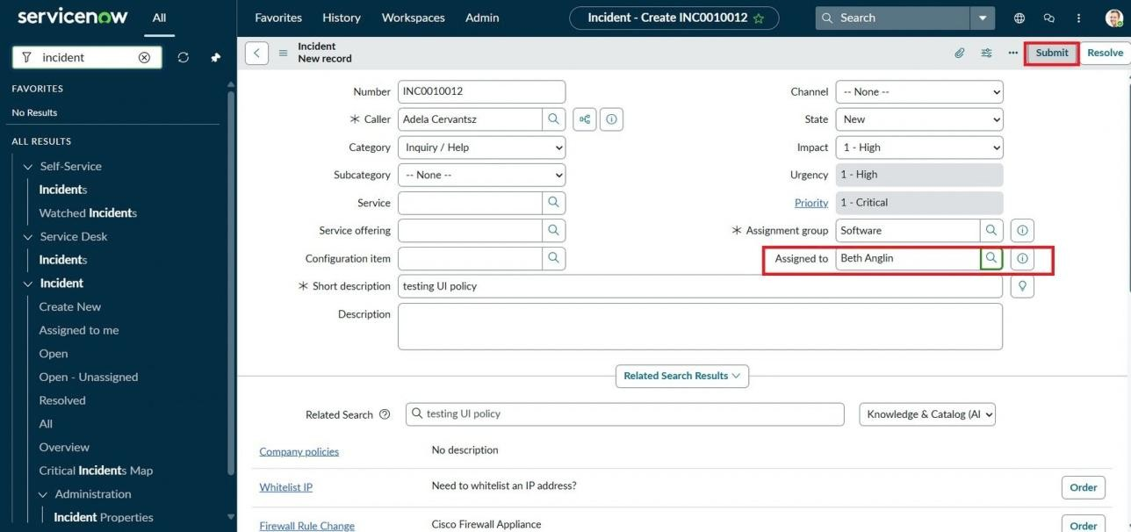
Testing screenshot – successful Incident configuration

Activity 3: Reverse Condition Test
- Open an existing Incident where Impact is High.
- Change Impact from High to Medium.
- Verify that Assigned To is no longer mandatory and Urgency becomes editable.
- Click Submit to save the changes.
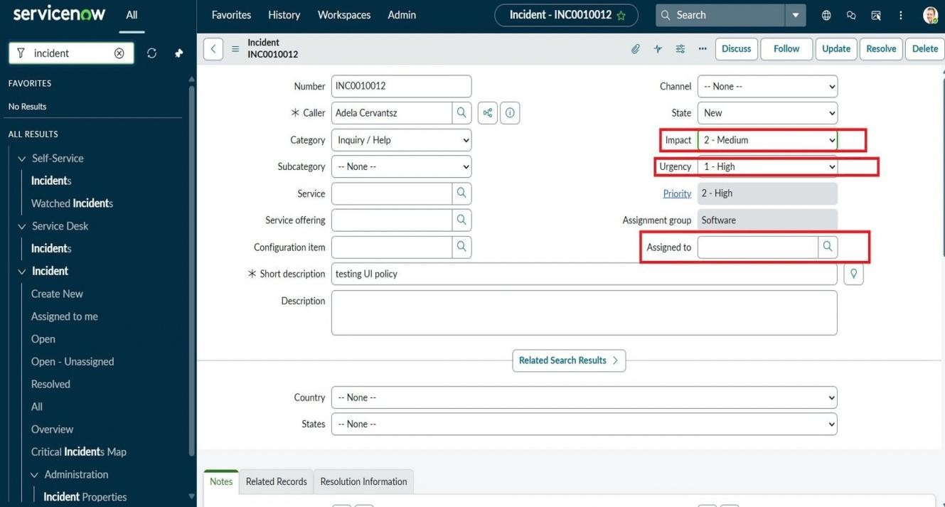
Testing screenshot – reverse condition behavior

Activity 4: Test List Edit Blocking
- Navigate to Incident → All to view the Incident list.
- Attempt to edit the State field directly from the list.
- Verify that an alert appears and the State value remains unchanged.

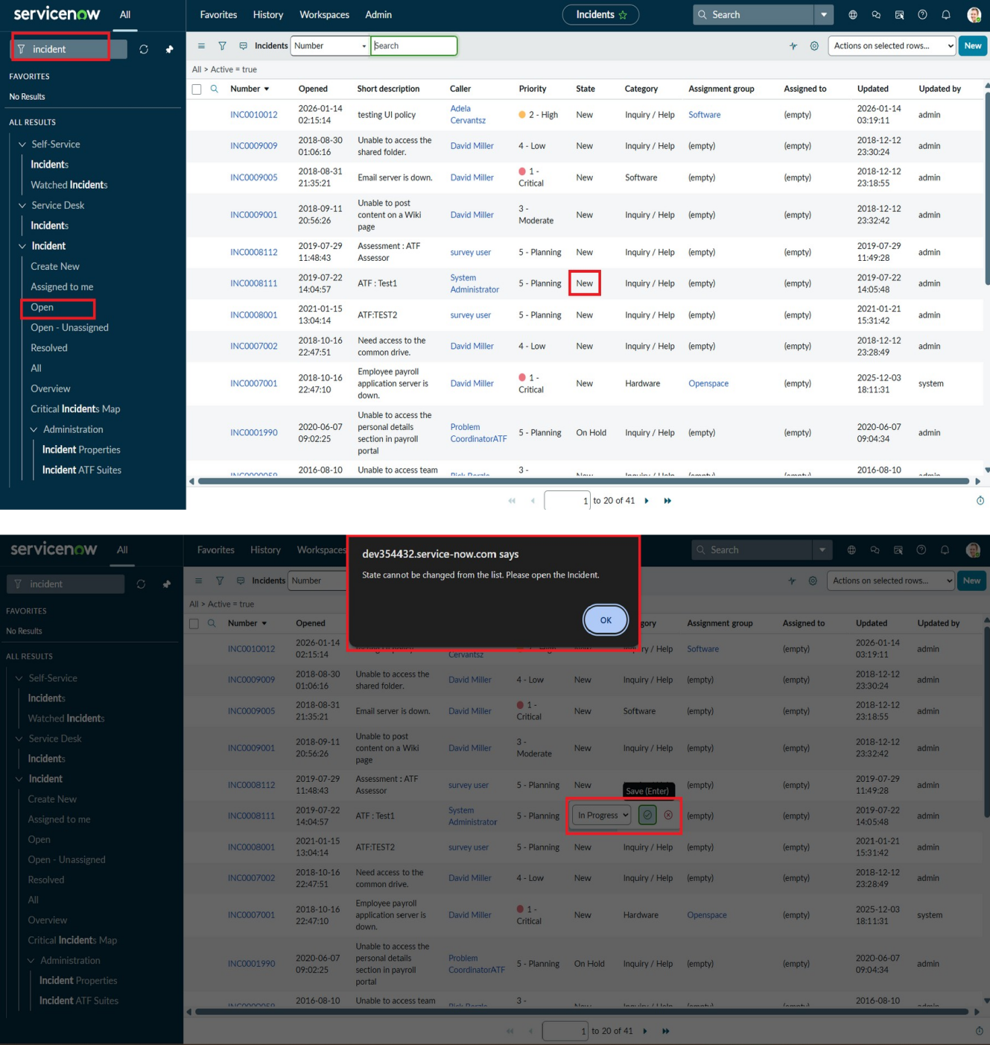

Testing screenshot – State list-edit blocking

Activity 5: Test Form-Based Update
- Open the same Incident record from the list.
- Change the State field on the Incident form.
- Click Update.
- Verify that the State change is saved successfully and the other configured controls remain effective.

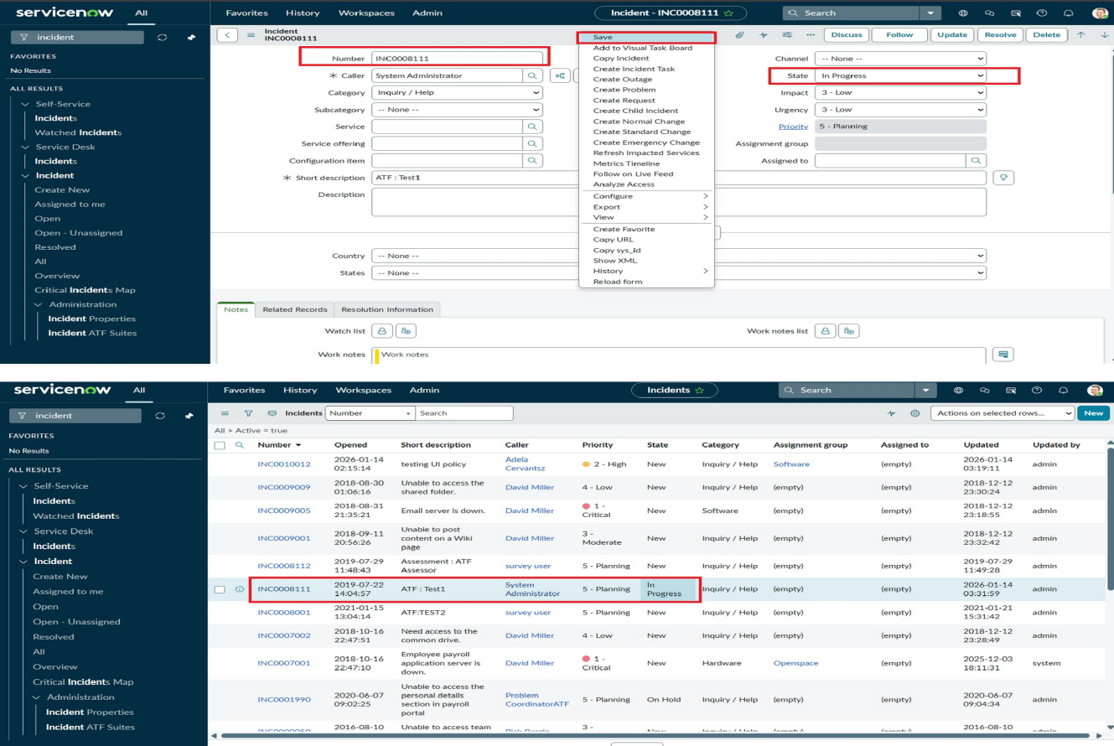
Testing screenshot – form-based State update

Milestone 4: Conclusion
The Implement Client Script & UI Policy (Incident) micro project demonstrates how ServiceNow UI Policies and Client Scripts can work together to enforce dynamic form behavior, automate updates, validate user input, and prevent incorrect data submission. The configuration supports consistent Incident data entry and helps maintain data quality and consistency while remaining lightweight and efficient for a micro project.

